Weather instrument: An anemometer
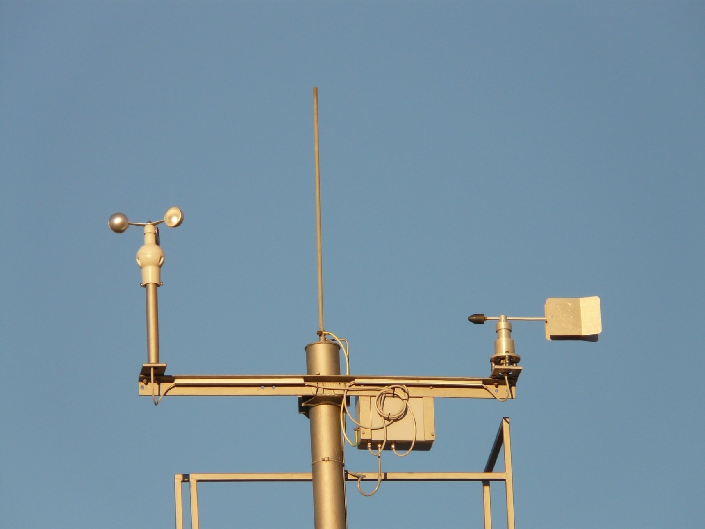
https://pixabay.com/en/weather-station-anemometer-5580/

